FloodLAMP assay cart drawer arrangement
Contents of each of the four drawers to be used in the FloodLAMP assay cart are as described and illustrated in the sections below.

STRIPS ONLY | PLATES
Drawer 1  - 48 Strip-of-8 tubes in tip box (2)  - 12 Strip-of-8 caps in 50 mL Falcon tubes (8)  - 50 1.5mL snap cap tubes in cryobox (1) | Drawer 1  - 48 Strip-of-8 tubes in tip box (2)  - 12 Strip-of-8 caps in 50 mL Falcon tubes (8)  - 50 1.5mL snap cap tubes in cryobox (1)
Drawer 2  - 1.5mL tube rack (1)  - Flipper rack (1)  - Versirack (1)  - PCR racks (2)  - Razor blades (10) | Drawer 2  - 1.5mL tube rack (2)  - Flipper rack (1)  - Versirack (1)  - PCR racks (2)  - Razor blades (10)
Drawer 3  - Saline filled Falcon tubes (15)  - Saline filled 30mL Chub tubes (5)  - 100X Inactivation Solution (1)  - 50mL Falcon tubes (10) | Drawer 3  - Pipette 100-1000uL (1)  - Pipette 10-100uL (1)  - Pipette fixed 2uL (1)  - 1000uL tips (1)  - 200uL tips (1)  - 10uL tips (1)  - Saline filled Falcon tubes (15)  - Saline filled 30mL Chub tubes (5)  - 100X Inactivation Solution (1)
Drawer 4  - Pipette 100-1000uL (1)  - Pipette 10-100uL (1)  - Pipette fixed 2uL (1)  - 8 channel pipette (1)  - Reagent reservoirs (5)  - 1000uL tips (1)  - 200uL tips (1)  - 10uL tips (1) | Drawer 4  - 8 channel pipette (1)  - Reagent reservoirs (5)  - PCR Plates (10)  - Plate Seals (10)  - Plate Roller (10)

Drawer 1
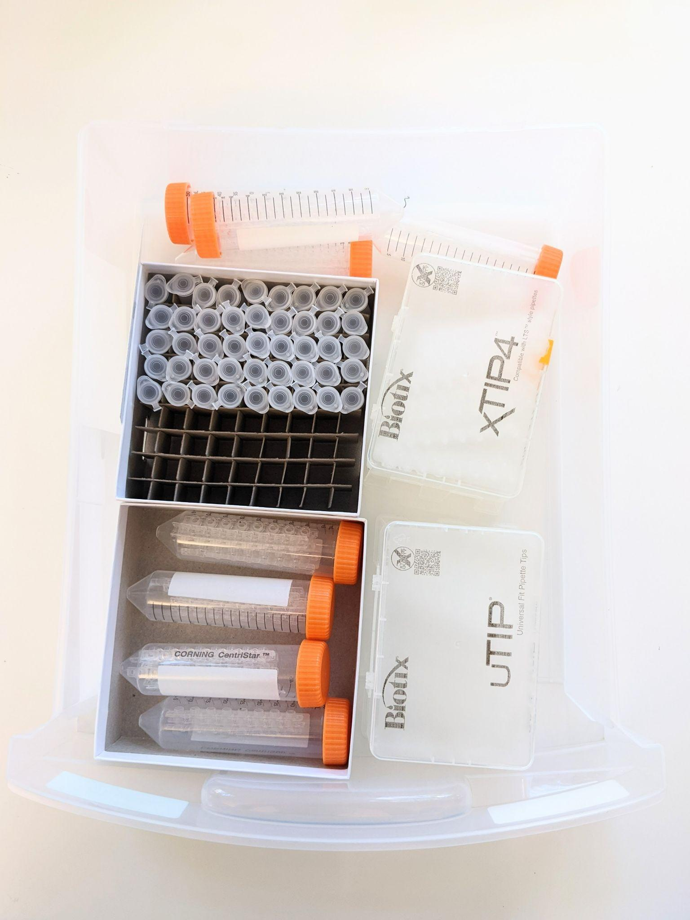

Drawer 2

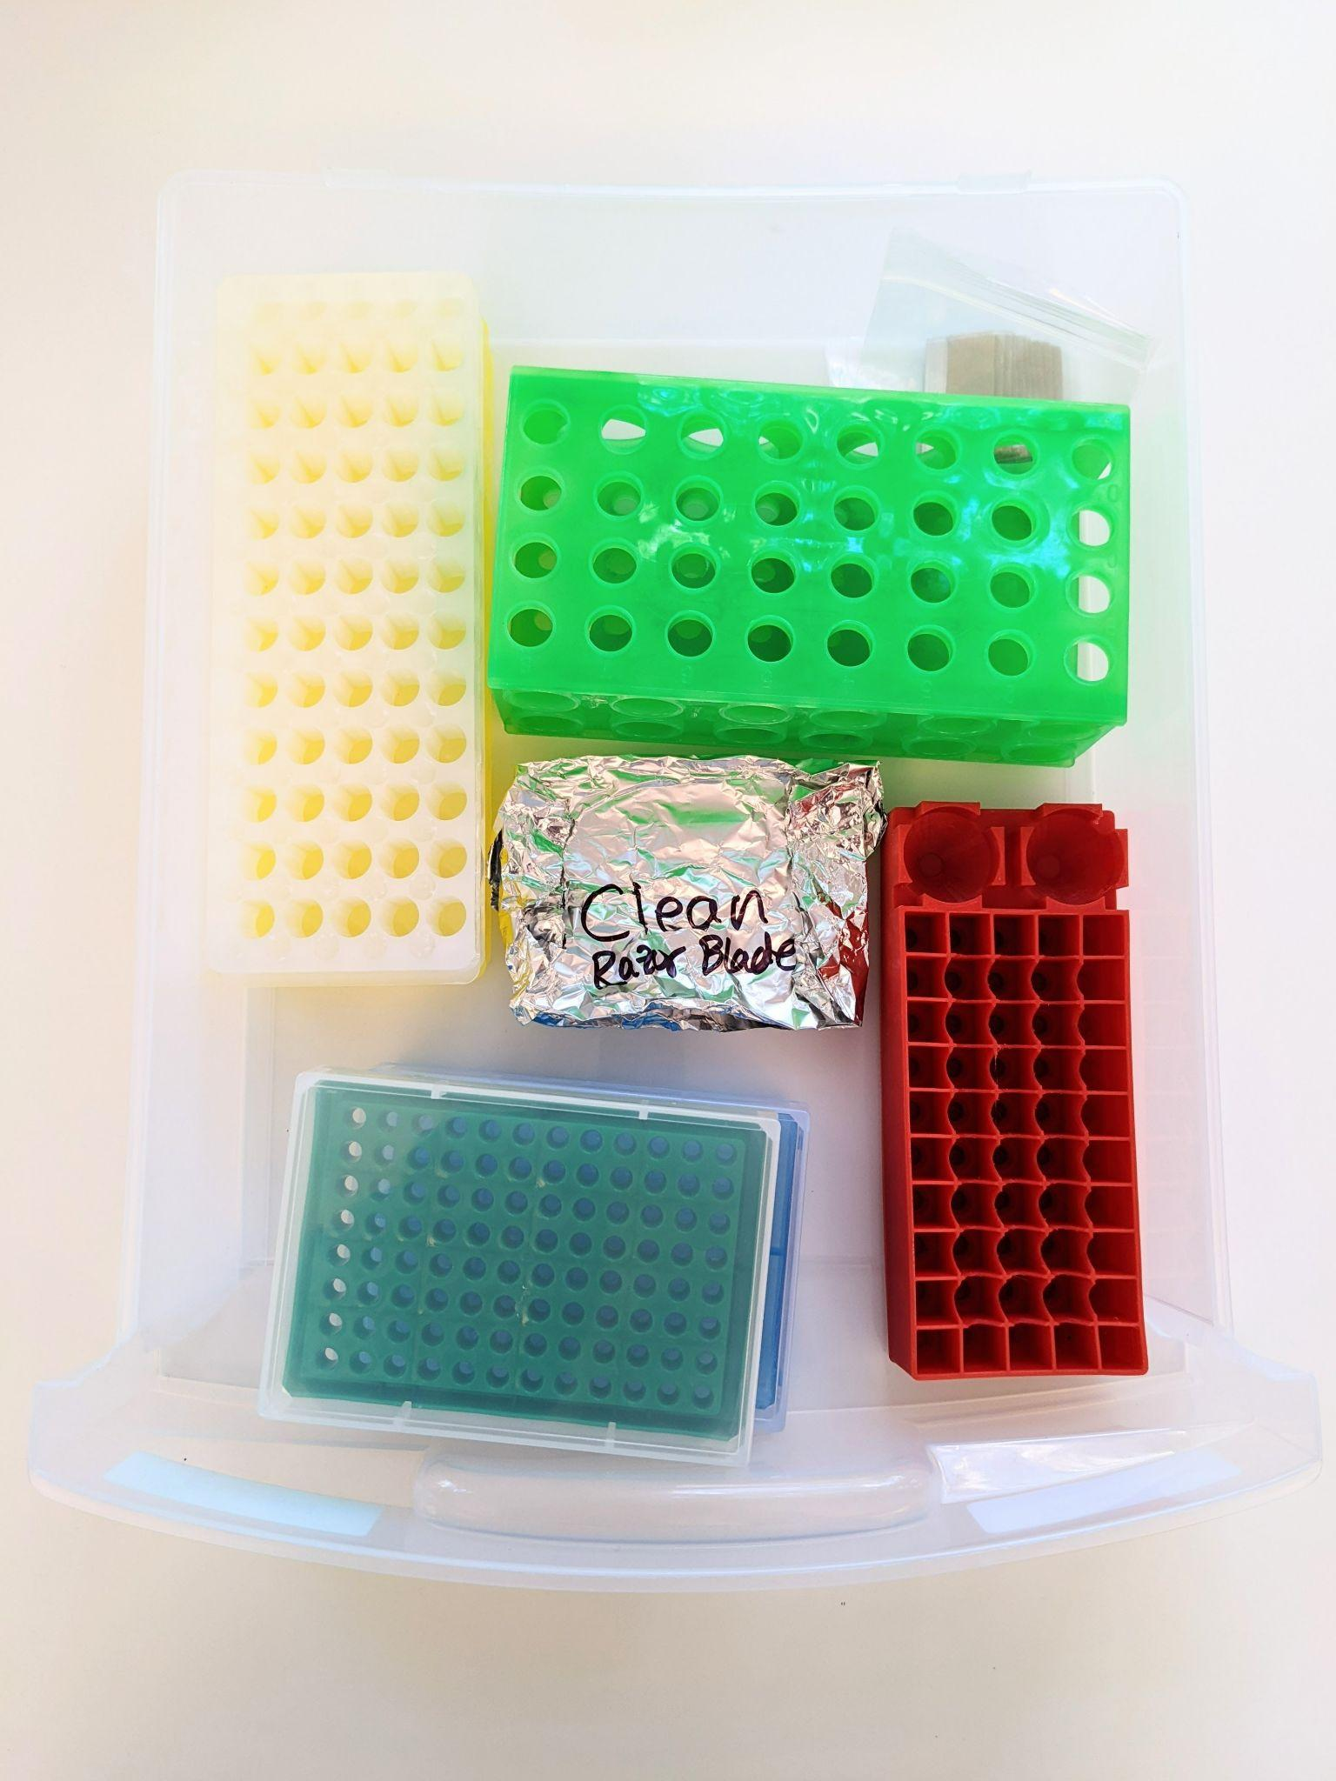

Drawer 3

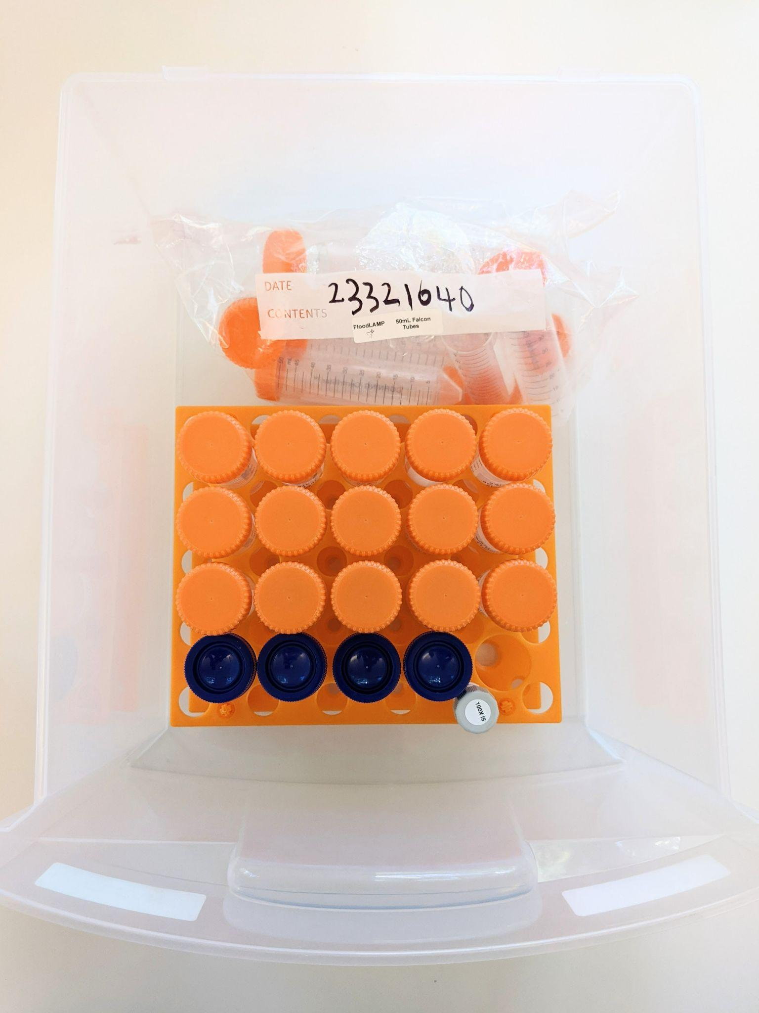

Drawer 4

